10.3: Taking positive torques to be counterclockwise (out of the page),
so the net torque is 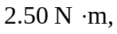with the direction counterclockwise (out of the page). Note that for 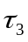 the applied force is perpendicular to the lever arm.

